OPERATING SYSTEMS
INTRODUCTION TO OS

(Relevance of Operating System)
1. You must have interacted with the operating systems when working on your laptop or mobile phones like windows, Mac OS, Android, iOS etc.
Think of a common scenario of copying a file and pasting the contents to another file in your computer system. Do you think operating systems play any role in performing this task? If yes, explain how operating systems do that.
Moreover, use this opportunity to think of more situations in which operating systems play a key role.

SOLUTION DESCRIPTION:
Yes, the operating system plays a pivotal role in making this task easier for us. When we are copying the contents of one file to another, then we are writing on a storage disk. Operating systems take care of this, as you must have observed that copying and pasting contents functionality works on your new laptop, even before you have installed any new application. This is because the operating system provides this support to us

(Mapping of Computer Hardware)
2. The example of the manager and the restaurant is made analogous to the operating system and computer system. Users are correctly mapped to customers, Waiters are correctly mapped to applications and the manager of the restaurant is mapped to the operating system. All the other resources in the kitchen of the restaurant are mapped to hardware resources of the computer system.

Can you match the following hardware resources to their appropriate counterpart in the kitchen of a restaurant?

Hardware resources | Resources in kitchen of a restaurant
1. CPU of the computer | a. Countertop
2. Main Memory or RAM | b. Cupboard
3. Disk | c. Chef at the restaurant

Note: Countertop or kitchen bench is the horizontal bench where the chef keeps all his required vegetables and equipment to prepare the food.
a) 1 - c, 2 - a, 3 – b b) 1 - c, 2 - b, 3 - a
c) 1 - b, 2 - a, 3 – c d) 1 - a, 2 - b, 3 – c
SOLUTION DESCRIPTION:
The example of the manager and the restaurant is made analogous to the operating system and computer system. Users are correctly mapped to customers, Waiters are correctly mapped to applications and the manager of the restaurant is mapped to the operating system. Using this information we can derive the following
1. CPU or Central Processing unit of the system works as the processing unit which transforms raw data (Input) into the processed data(Output), it seems like a function of the Chef in the restaurant as the chef converts raw ingredients to incredible dishes
2. Main memory or RAM is a device or system that is used to store information for immediate use in a computer or related computer hardware and digital electronic devices. The CPU processes the data which is stored in Main Memory or RAM. It should be matched with the countertop as the food or raw material is placed at the countertop by the chef while making dishes
3. The Hard Disk stores all the data whether it is in execution or not. This should be matched with the cupboard because in the kitchen all the things are stored in the Cupboard.

(Composition of Operating System)
3. From the analogy explained in the lecture video, it is clear that the OS acts as an interface between applications and hardware and the users interact with applications to get their tasks done. This diagram explains the interface between various actors in our discussion:

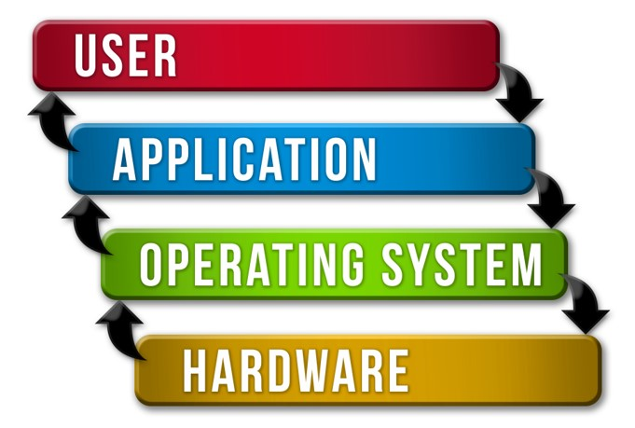

According to you, what is an operating system made of?
a) Collection of hardware components b) Collection of input-output devices
c) Collection of software functions d) All the above
SOLUTION DESCRIPTION:
An operating system (OS) is a collection of software functions that is responsible for the management of computer hardware, software resources, and also provides common services for computer programs.

(Removal of Operating System)
4. What will happen if you remove the operating system from the following diagram?

SOLUTION DESCRIPTION:
1. If we remove OS from the computer system, then one of the immediate consequences will be that applications will become bulky and complicated. This will happen because each application has to include code for interacting with each hardware. This code was earlier written in OS and all the applications used to use that common code to interact with hardware.
2. The hardware resource will not be managed. Each application will have privileged access to the hardware. Due to this, there can be complete chaos. It may happen that one application is using all the CPU and using all the memory and other applications are waiting to use these resources.
3. Modern OS provides isolation and protections to applications. Programs cannot write in memory of other programs. Earlier OS like Microsoft DOS didn't provide memory protection.

(Code Sharing by OS)
5. Let us rephrase a function of OS.

There are certain tasks that repeatedly performed by the applications, such as writing contents to a storage location on Hard Disk. Now, OS writes the code of this task at one place and let all the applications use this code. This code sharing feature saves application from writing the same code again and again in their source code.

Which of the following functions of OS does this code sharing feature map to?
a) OS acts as an interface between applications and hardware
b) OS acts as a resource manager
c) OS hides the hardware complexity
d) OS makes it easier for user to use the hardware.
SOLUTION DESCRIPTION:
The function with which it correctly maps to is that OS acts as an interface between hardware and applications.

(Choose the correct option)
6. Choose the correct function of OS for the following example:

Example: A user using different vendors of speakers on the same computer system.
a) Arbitration b) Abstraction
c) Abstraction as well as arbitration
SOLUTION DESCRIPTION:
Let’s say that the user has a speaker of X brand and a Y brand. The user just gives the command to the computer to connect to whichever speaker he/she wants to connect without knowing the underlying complexity. This is a part of abstraction.
An abstraction is a software that hides lower-level details and provides a set of higher-level functions. An operating system transforms the physical world of devices, instructions, memory, and time into a virtual world that is the result of abstractions built by the operating system.

(Choose the correct option)
7. Choose the correct function of OS for the following example:

Example: Interchangeable access to hard disk and SSD disk.
a) Arbitration b) Abstraction as well as arbitration
c) Abstraction
SOLUTION DESCRIPTION:
Interchangeable access to hard disk and SSD disk is an example of abstraction. This is because the user doesn't know the backend process regarding the interchangeable access to hard disk and SSD disk, as well as the user doesn't know when the access is shifted from hard disk to SSD by the CPU. So, the CPU hides the complexity behind the Interchangeable access to the hard disk and SSD disk. This is an example of abstraction.

(Choose the correct option)
8. Choose the correct function of OS for the following example:

Example: A user using pen digitizer to write on the screen of the computer system.
a) Arbitration b) Abstraction
c) Abstraction as well as arbitration
SOLUTION DESCRIPTION:
To connect the pen digitizer with the computer system the user just asks the operating system to Connect. The user has no idea what is the underlying working of the command, hence it is an example of Abstraction.

(Similar Examples)
9. Look at the following tasks done by the OS:

1. The distribution of memory among different applications
2. Different applications running on the computer system

These examples were explained in the lecture video. In both of these examples, OS was doing abstraction as well as arbitration.
How are these two examples different from each other? Also, can you justify the functions of the OS in these examples?

SOLUTION DESCRIPTION:
The examples are different from each other because the focus is on different devices.
1. Distribution of memory among apps is managing main memory
2. Running different apps on the computer system needs the execution of instructions and this is taken care of by the CPU.
In these examples, the details of how memory is managed between different applications and how different applications are running simultaneously are hidden from the user. Hence, these are examples of abstraction.
Arbitration happens when the OS has to manage a resource and distribute the resource between different applications. Here, CPU and main memory are distributed between different applications, hence, this is a case of arbitration.

(Primary Use of Operating System)
10. Which of the following choices best describes the functions of an operating system?
a) To make the most efficient use of computer hardware
b) To allow people to use the computer
c) To keep system programmers employed
d) To make it difficult for layman users to damage the computer system
SOLUTION DESCRIPTION:
The primary function of operating systems is to optimally utilize the hardware resources. It has to act as a resource manager and employ its hardware resources in such a way that it makes the most efficient use of computer hardware.

(Components of Operating System)
11. Which of the following are the parts of the kernel of an operating system:
a) File manager b) File editor c) Cache memory
d) I/O manager e) Web browser f) Process manager
SOLUTION DESCRIPTION:
The main functions performed by the kernel are:
File Management: The kernel is responsible for file storage and file management. It keeps track of free space when a file is created, updated, or deleted, the date and time of creation, modification, and deletion of a file. It also manages the ownership and permissions of the files.
Input-Output Management: I/O devices are any external devices like the keyboard, disk, network devices, audio devices, etc. The I/O management functionality of the kernel is responsible for managing all such devices.
Process management: When we run a program or an application on a computer, it creates a process. There are several programs that we run on the computer. The order the program should run, the number of resources they should consume, and how long they should run are all managed by the process management capabilities of the kernel. It is also responsible for the creation, termination, scheduling, and resolving the deadlock of a process.
Memory Management: The operating system is responsible for managing the resources. Actually, It is the kernel that helps the operating system do this job. It makes sure that applications have enough memory so that they can run. It is also responsible for optimizing memory. We’ll discuss this in more detail when we are in the third module.

(Kernel Functionalities)
12. If you have to copy the contents of a file called "cn.txt" in one of your folders to another folder. Assume the name of file in another folder is "cncopy.txt".

To complete this process, OS first reads all the contents from "cn.txt" and stores it into the memory and then OS writes all the contents to "cncopy.txt".

Match the following tasks to the appropriate kernel functionality involved in it:

Task | Functionality
1. Reading the contents of a file | a. Memory Management
2. Copying the file contents into the memory | b. Process Management
3. Whole process of copying and pasting the contents of file | c. File Management

a) 1-a, 2-b, 3-c b) 1-b, 2-c, 3-a
c) 1-b, 2-a, 3-c d) 1-c, 2-a, 3-b
SOLUTION DESCRIPTION:
1. The process of reading the contents of a file involves doing reading and writing operations on the file. This will come under file management.
2. The process of Copying the file contents into the memory involves the changes in the memory of the system. It will surely come under memory management.
3.The whole process of copying and pasting the contents of the file is a process for which the CPU is responsible. So it will surely come under process management.
So the solution is 1-c,2-a,3-b

(Hybrid Kernel)
13. Why do you think the Hybrid kernel has better performance than Microkernel and small size in comparison to the Monolithic kernel?

Diagram for your reference:

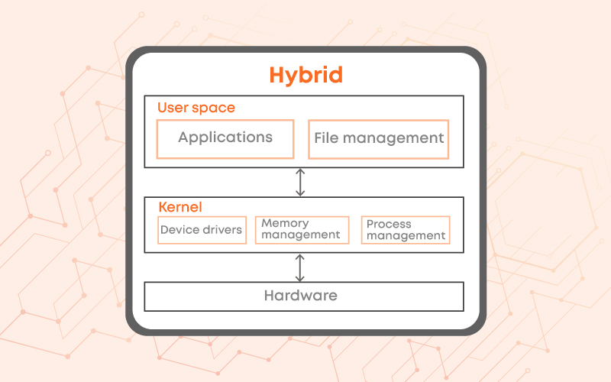
SOLUTION DESCRIPTION:
As clearly evident in the diagram of Hybrid Kernel, the file management module is not part of the kernel. Hence, the size of the kernel module in the Hybrid kernel is smaller in comparison to Monolithic Kernel.
The addition of modules in user space increases the overhead of switching between user mode and kernel mode. In Microkernel, there are two modules in user space, in comparison to only one module in Hybrid kernel and hence, Hybrid kernel has less overheads of switch and better performance than Microkernel.

(System Calls)
14. System calls are invoked by using:
a) A software interrupt b) Polling
c) An indirect jump d) A privileged instruction
SOLUTION DESCRIPTION:
Software interrupts are used to implement transitions between modes of operations such as system calls.

(Match the following)
15. Match the following for system calls listed in List-1 with appropriate

List-1 | List-2
a. exec() | 1. Creates a new process
b. exit() | 2. Keeps the process id same and replaces the running code with a new code
c. wait() | 3. Terminates a running process properly
d. fork() | 4. A process synchronizes with termination of child process

a) (a) - 2, (b) - 3, (c) - 4, (d) – 1 b) (a) - 2, (b) - 3, (c) - 1, (d) - 4
c) (a) - 3, (b) - 2, (c) - 4, (d) – 1 d) (a) - 4, (b) - 2, (c) - 1, (d) – 3
SOLUTION DESCRIPTION:
1. exec(): this function is used to execute a file that is residing in an active process.
2. exit(): It terminates a running process properly. It performs operations like flushing unwritten buffer data, closing all open files, removing temporary files. In the end, it returns an integer exit status to the operating system.
3. wait(): The wait() system call synchronises and suspends execution of the current process until one of its children terminates
4. fork(): This system call is used in the creation of new processes

(Commands Exploration)
16. Let's say you have a process running on your system with process id 3851.
Now, you have to run the following commands in Bracket - 1 and match them to their appropriate outputs in Bracket – 2

Bracket - 1 | Bracket - 2
1. kill 3851 | a. Passes a keyboard interrupt to the running process
2. kill -9 3851 | b. Abruptly terminates the running process
3. kill -2 3851 | c. Properly terminates the running process
4. kill -l | d. Lists all the available signals that can be passed to kill command

a) 1 - c, 2 - d, 3 - a, 4 – b b) 1 - c, 2 - b, 3 - a, 4 - d
c) 1 - a, 2 - b, 3 - c, 4 – d d) 1 - c, 2 - a, 3 - b, 4 – d
SOLUTION DESCRIPTION:
1. Kill: This command is used to properly terminates the running process
2. Kill-9: This command will abruptly terminate the running process
3. Kill-2: This command will pass keyboard interrupt to the running process
4. Kill -l: This Command will list all the available signals that can be passed to kill a command
So the answer is option B.

(Information Management Calls)
17. Functions of some of the information management calls or system calls are listed below.

1. System call to find data and time of the system
2. Call to find free space on the disk
3. System call to find allocated and free memory

These system calls have wrapper terminal commands as well.

Explore the internet to find these wrapper commands.
SOLUTION DESCRIPTION:
date is the command to find data and time of the system.
df is one of the commands to find free space on the disk.
free is one of the commands to find allocated and free memory.
Note: We recommend you to explore internet to learn more about these commands.

(Choose the correct option)
18. Choose the correct statements in relation to system calls and commands of the terminal?
a) Operating systems are mostly implemented in C. System calls are function calls to implementations of functions where they interact with hardware resources.
b) Terminal commands are a wrapper over the system calls. Behind the scenes of terminal commands are function calls to the system calls.
c) System calls are used to interact with the kernel of Operating systems.
d) All the above statements are correct.

(Commands Exploration)
19. As you have installed the Linux OS on your system, you have tried the commands explained in the lecture video on the terminal and you have explored the man pages of various commands, as explained in the note.

Let us try out a few more commands. Before trying these commands, create two files in the home folder by using using following command: cat >newfile.txt

After writing this command, the prompt will not be returned back to you, after pressing enter key. So, whatever you will write on the terminal, it will become the contents of your file: newfile.txt. So, let’s write “Welcome to Coding Ninjas Operating Systems Course” and press Ctrl + C to terminate the process of writing to this file. Similarly, create another file with the name “anotherfile.txt” and write “Let’s try out some commands” in it.

Now, you have to run the following commands in Bracket - 1 and match them to their appropriate outputs in Bracket – 2

Bracket - 1 | Bracket - 2
1. cat newfile.txt | a. It will append the contents of one file to another
2. cat newfile.txt anotherfile.txt | b. It will show content of a file with line number
3. cat -n newfile.txt | c. It will show the contents of both newfile.txt and anotherfile.txt
4. cat newfile.txt >> anotherfile.txt | d. It will show the contents of newfile.txt

a) 1 - a, 2 - c, 3 - b, 4 – d b) 1 - d, 2 - c, 3 - b, 4 - a
c) 1 - d, 2 - b, 3 - c, 4 – a d) 1 - a, 2 - b, 3 - c, 4 – d

SOLUTION DESCRIPTION:
1. When the “cat” command alone and the single file is called it will show the contents of the file
2. When “cat” commands are used alone with multiple no files it will show the contents of all the files.
3. When the “cat -n” command is used it will show content with line number
4. “cat file1 >> file2” is used to append the content of one file to another

(Choose the correct option)
20. Select the correct definition for abstraction, mechanism and policies
a) Abstraction includes OS’s abstracted form of application as well as hardware resources, mechanism is how to do something and policies are what will be done
b) Abstraction includes OS’s abstracted form of hardware resources, mechanism is what will be done and policies are how to do something
c) Abstraction includes OS’s abstracted form of hardware resources, mechanism is how to do something and policies are what will be done
d) Abstraction includes OS’s abstracted form of application as well as hardware resources, mechanism is what will be done and policies are how to do something
SOLUTION DESCRIPTION:
1. Abstractions: Abstraction is the simplification of what hardware seems like, some OS abstractions are - a process, thread, file, socket, memory page, etc.
2. Mechanism: Mechanism is the implementation of the steps involved which determine how to perform some activities. Some common mechanisms are: open, write, allocate, create, schedule, etc.
3. Policy: Policy is the way to settle on which activity to perform, the maximum number of sockets that an application can have access to, what proportion of memory to allocate, etc. Some common policies are Least Recently Used also known as LRU, Earliest deadline first known as EDF, etc.

**********

